Batch: A1 Roll No.: 16010123012
Experiment No.: 1
Grade: AA / AB / BB / BC / CC / CD /DD

Title: Study of Cloud Computing & Desktop-as-a-Service (DaaS)
Objective: To study the fundamentals of cloud computing and to understand the concept of Desktop-as-a-Service (DaaS) through exploration of free-access and demo-based platforms.
Expected Outcome of Experiment:
CO | Outcome
CO1 | Comprehend the issues related to cloud computing and its application

Books/ Journals/ Websites referred:
OnWorks, Kasm Workspaces, BrowserStack, and LambdaTest
Related Theory: -

Part A: Study of Cloud Computing Concepts (Theory)

1. Types of Computing

a) Traditional / Standalone Computing
Definition:
Standalone computing refers to a computing model where all processing, storage, and applications run on a single local machine without network dependency.
Example:
Personal desktop computer with locally installed software (e.g., MS Word, Photoshop).
Advantages:
- No dependency on internet connectivity
- High data privacy and control
- Simple setup
Disadvantages:
- Limited scalability
- Data loss risk without backups

b) Client–Server Computing
Definition:
In this model, multiple client machines request services from a centralized server that manages data, resources, and security.
Example:
Banking systems, college ERP systems.
Advantages:
- Centralized data management
- Better security than standalone systems
- Easier maintenance and updates
Disadvantages:
- Server failure affects all clients
- Higher setup and maintenance cost
- Requires network connectivity

c) Distributed Computing
Definition:
Distributed computing divides tasks across multiple interconnected computers that work together as a single system.
Example:
Distributed databases, scientific simulations, Hadoop clusters.
Advantages:
- High performance and reliability
- Fault tolerance
- Efficient resource utilization
Disadvantages:
- Complex management
- Network dependency
- Higher coordination overhead

d) Cloud Computing
Definition:
Cloud computing provides on-demand access to shared computing resources such as servers, storage, and applications over the internet.
Example:
Google Drive, AWS EC2, Microsoft Azure.
Advantages:
- Scalability and flexibility
- Pay-as-you-use pricing
- High availability and accessibility
Disadvantages:
- Internet dependency
- Data security concerns
- Limited control in managed services
2. Cloud Computing Architecture
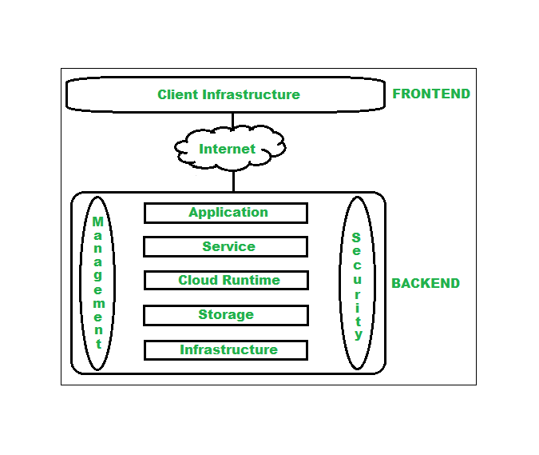
Part B: Desktop-as-a-Service (DaaS)
1. Definition of DaaS
Desktop-as-a-Service (DaaS) is a cloud computing service model in which a complete desktop environment is delivered to end users over the internet using centralized cloud infrastructure.

2. Common Features of DaaS
- Browser-based desktop access
- Centralized desktop management
- Device and location independence
- Cloud-based data storage
- Security and access control
- Scalability
- Minimal client-side requirements
Implementation Details:

Platform 1: OnWorks (Free Access)
Steps:

1. Visit https://www.onworks.net
2. Select an online Linux desktop (Ubuntu/Fedora)
3. Launch the desktop in the browser

4. Observe the user interface and functionality
5. Capture screenshot

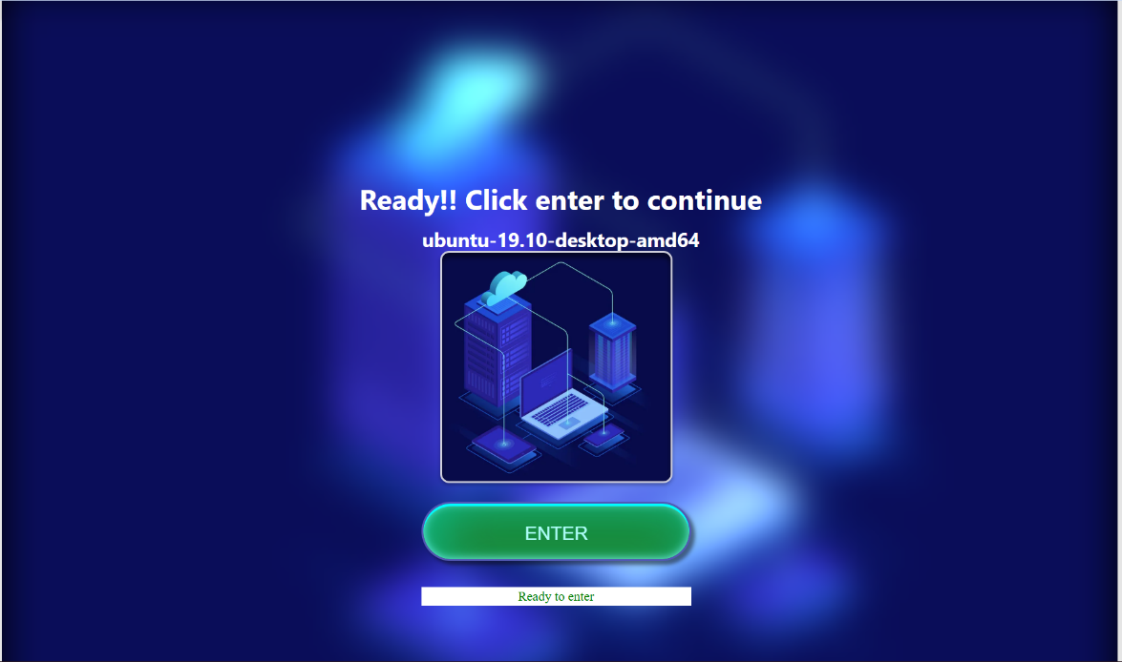

OnWorks homepage displaying available online operating systems for browser-based access.

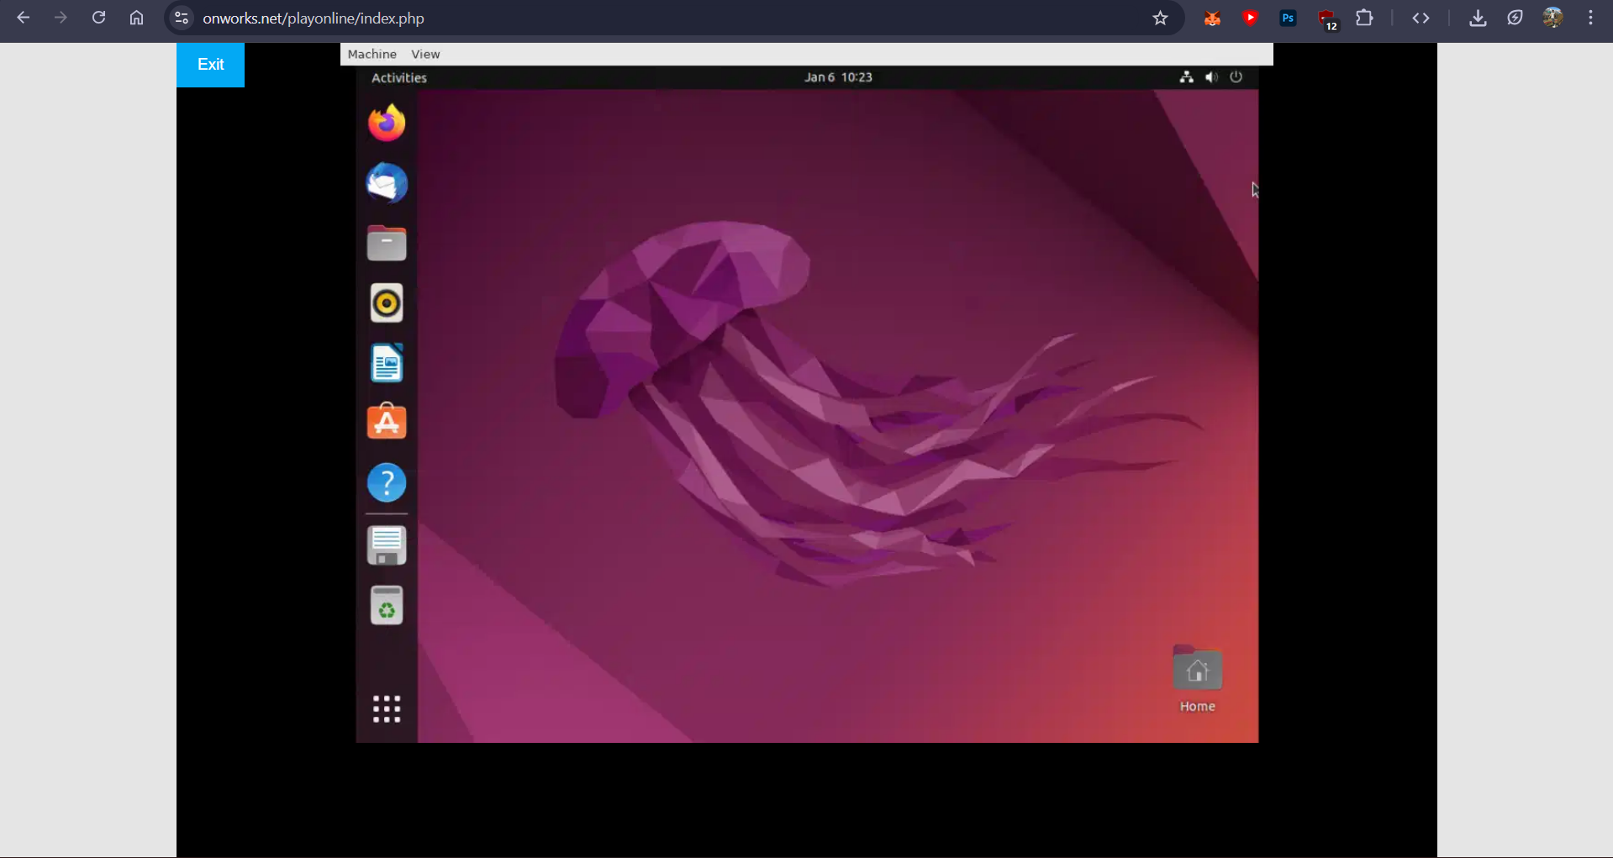
OnWorks cloud-based Linux desktop

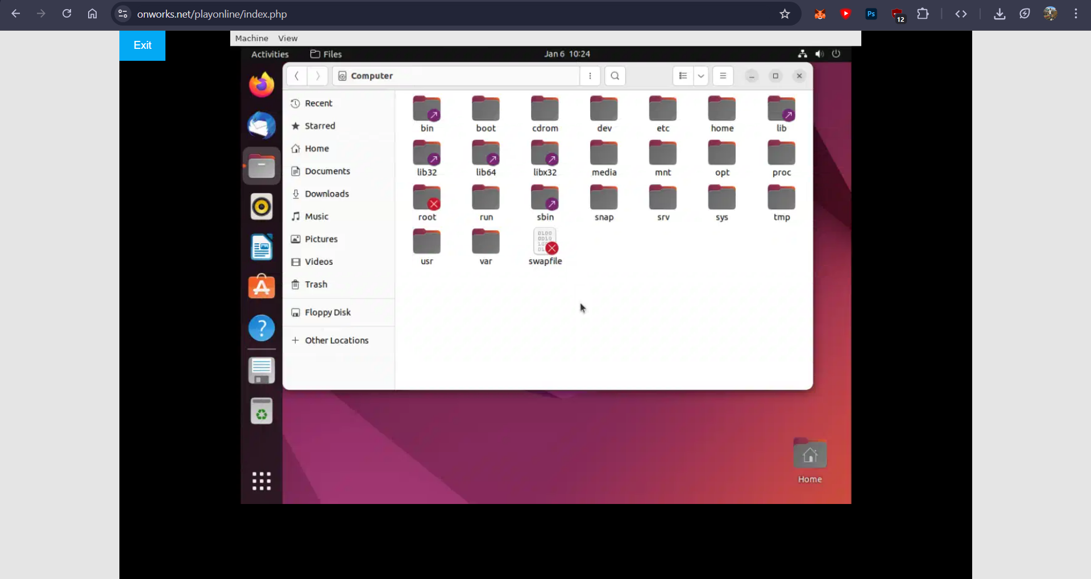
OnWorks cloud-based Linux desktop interface showing File system.
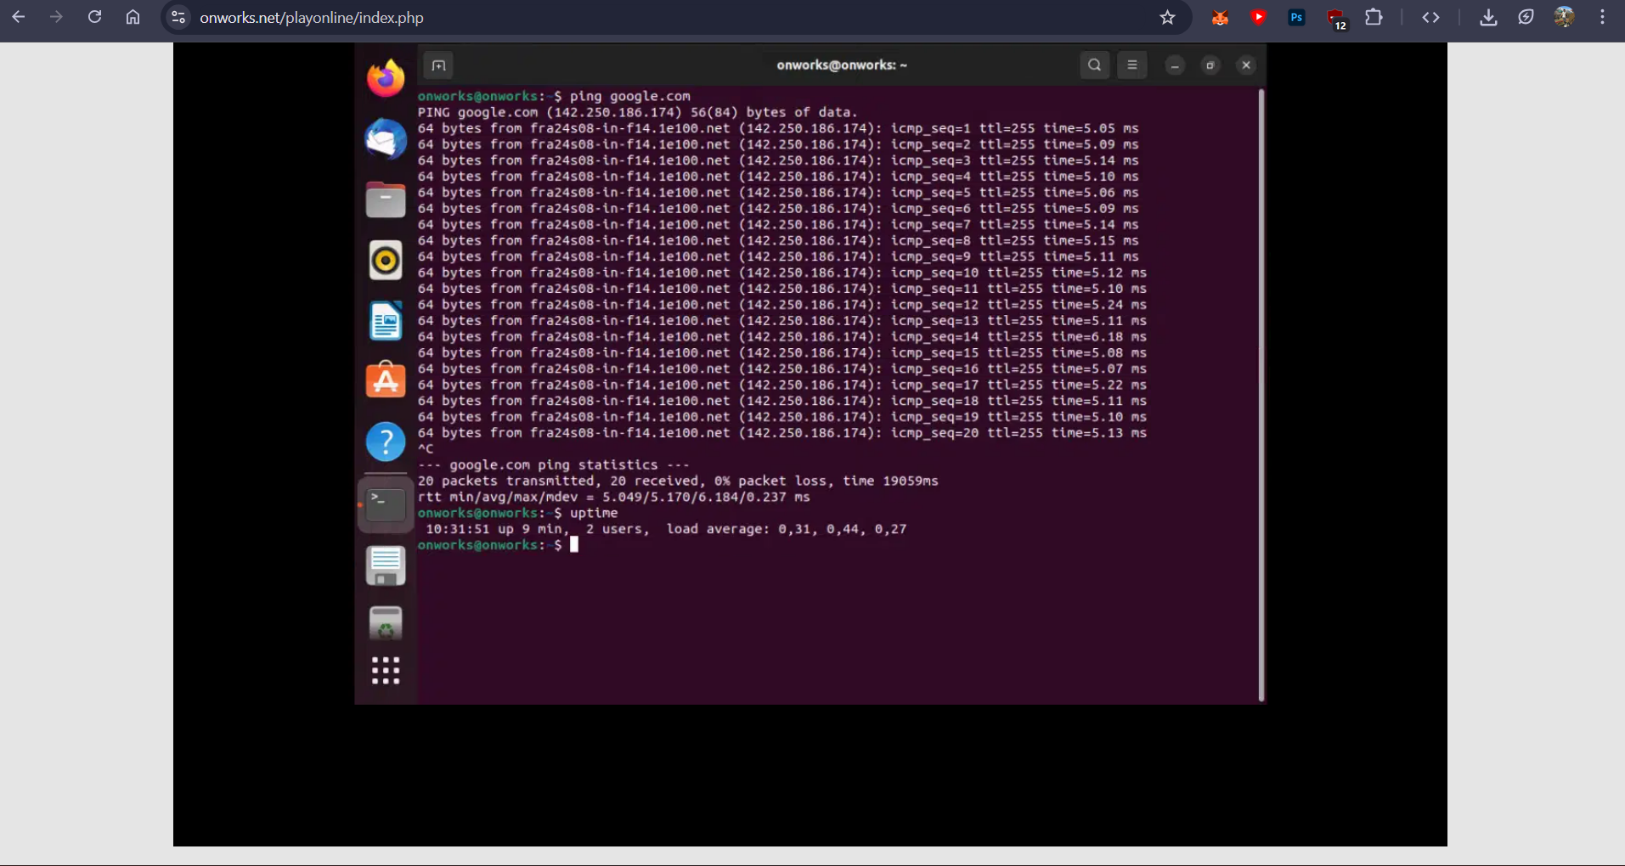
OnWorks cloud-based Linux commands in terminal

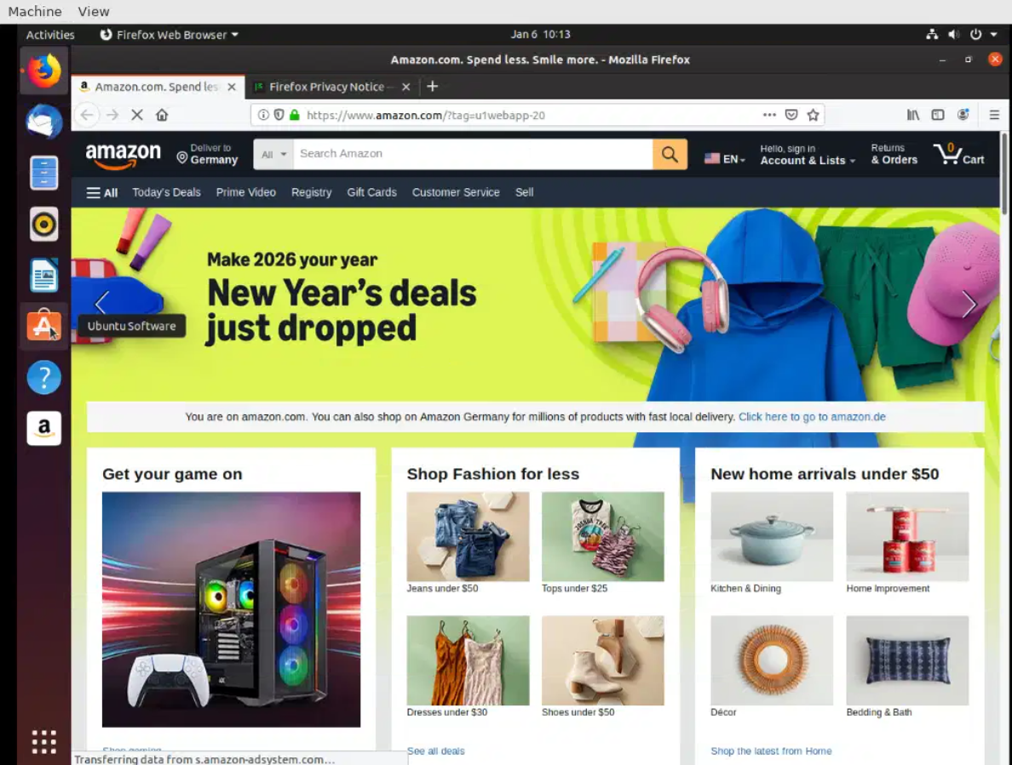
Ubuntu Linux desktop launched on OnWorks platform and Amazon opened on web browser.

Platform 2: Kasm Workspaces (Demo)

Steps:

1. Visit https://www.kasmweb.com

2. Access the demo workspace

3. Observe browser-based desktop streaming

4. Capture screenshots of the workspace

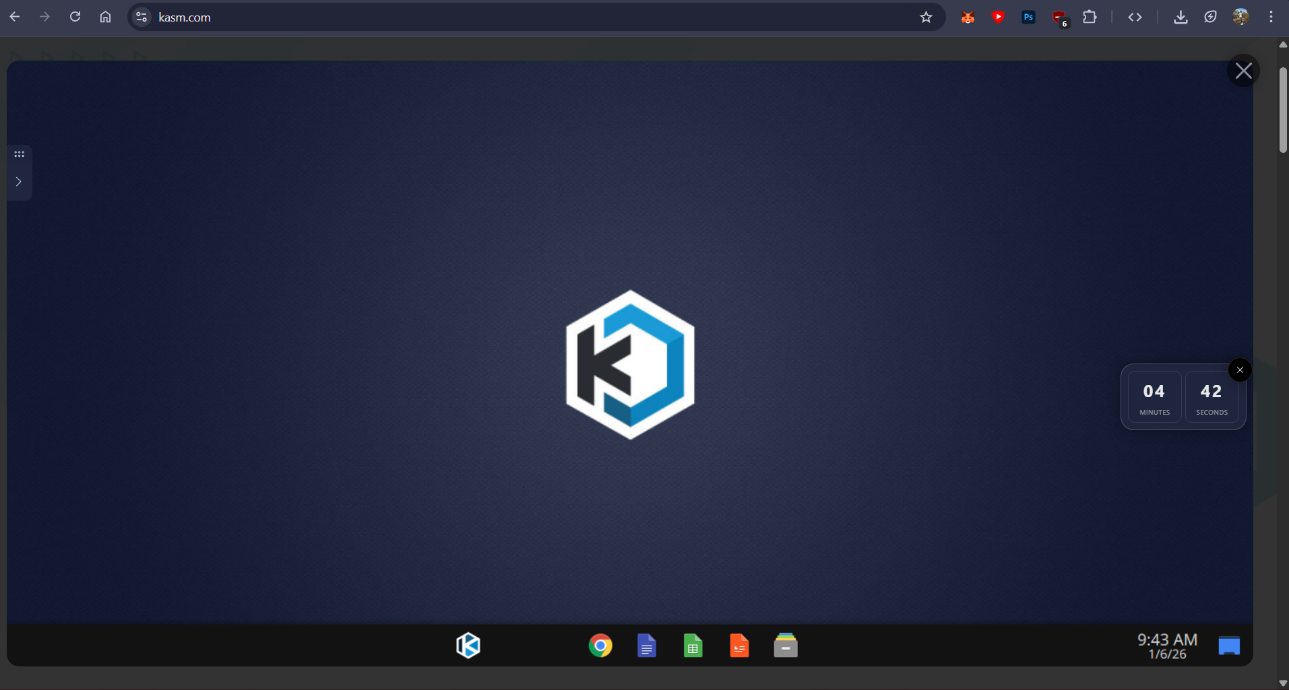

Main Srart on Kasm Workspace

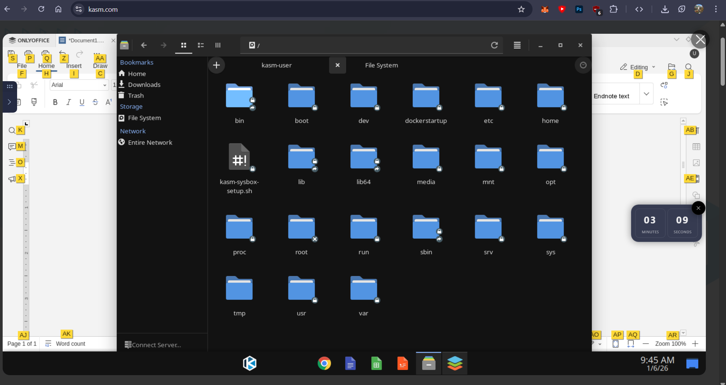

Using File System on Kasm Workspace

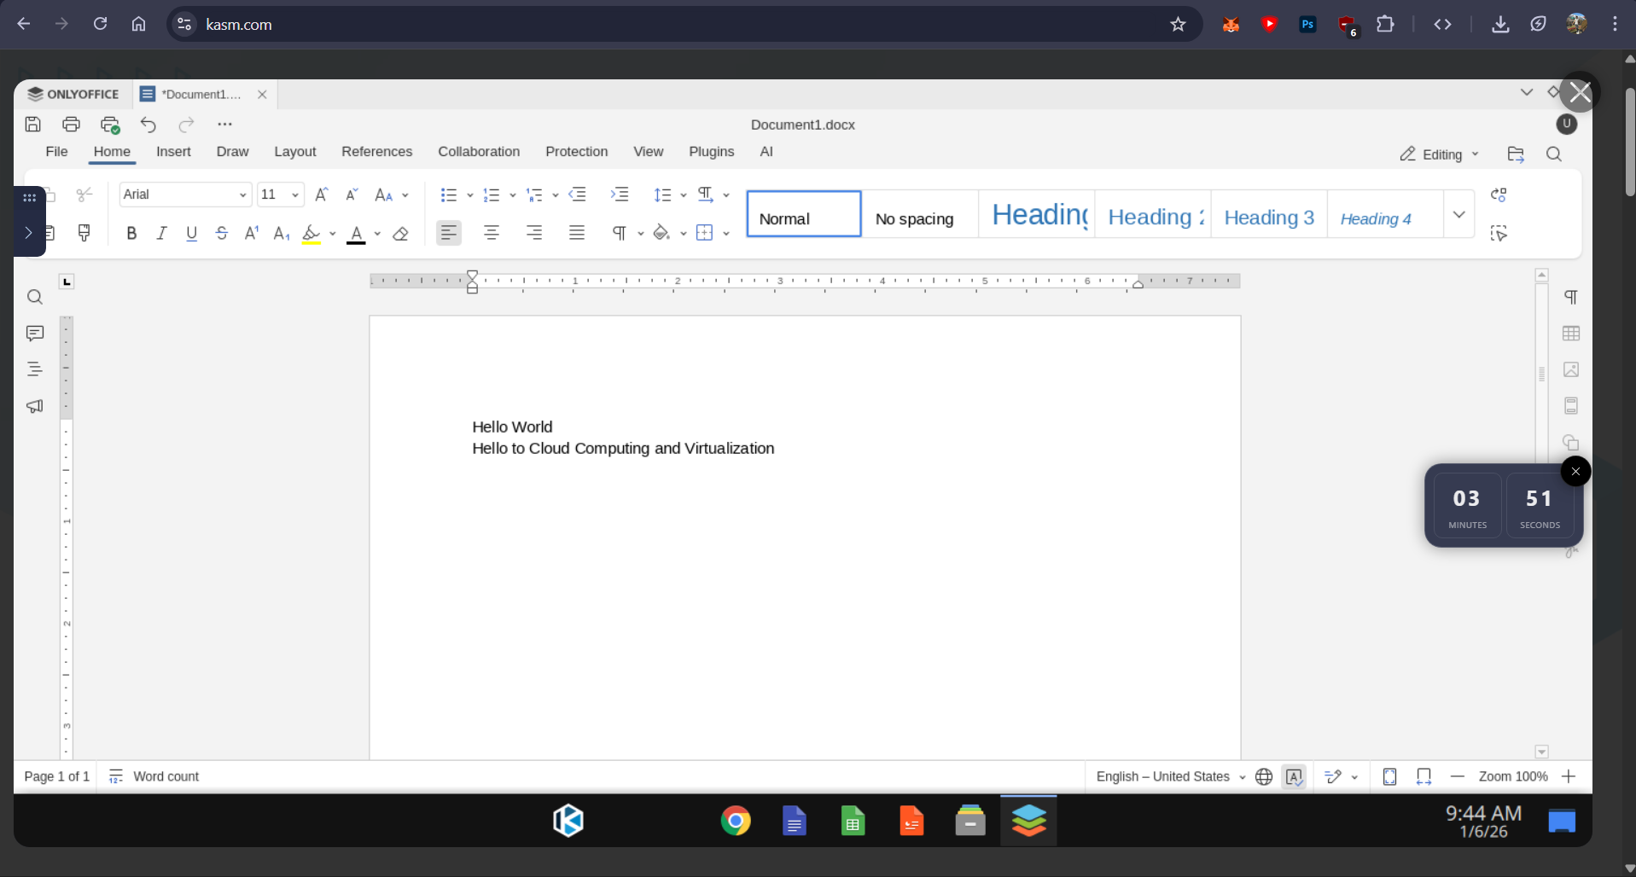
Using Kasm webspace to access Microsoft Word

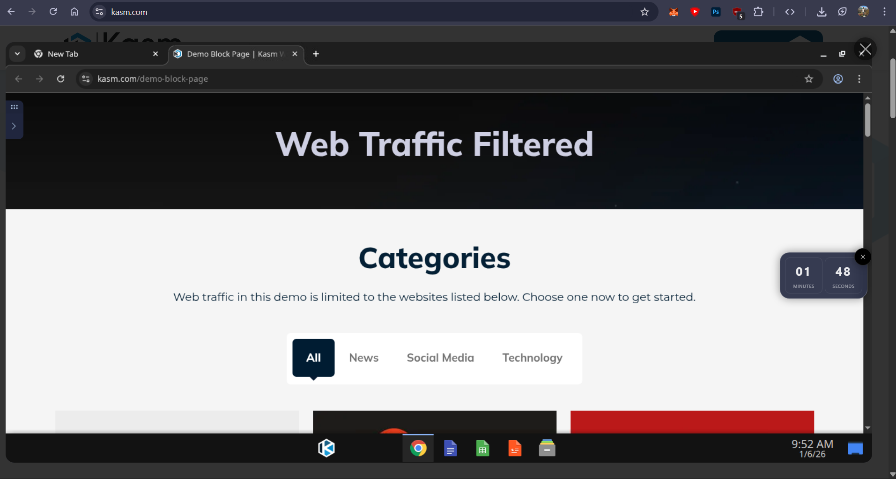

Using Kasm webspace to access Google Chrome

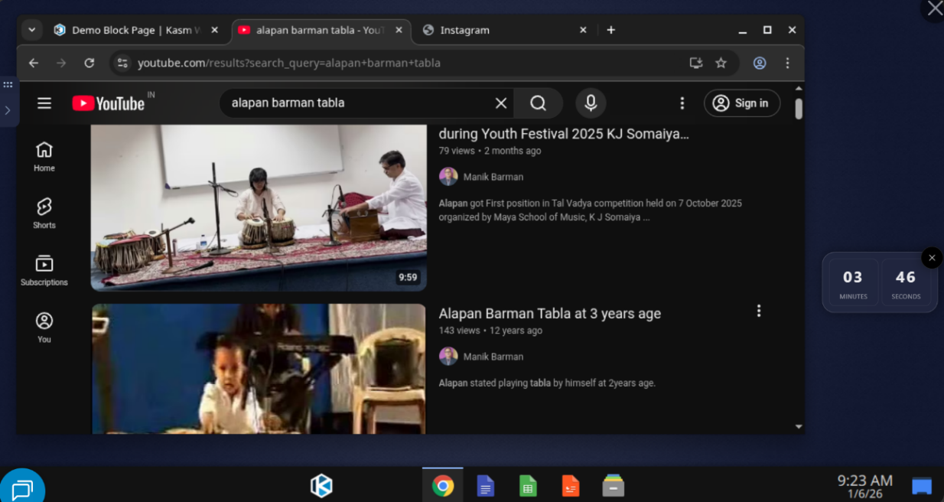
Using Youtube Streaming Service on Kasm Workspace

Platform 3: BrowserStack
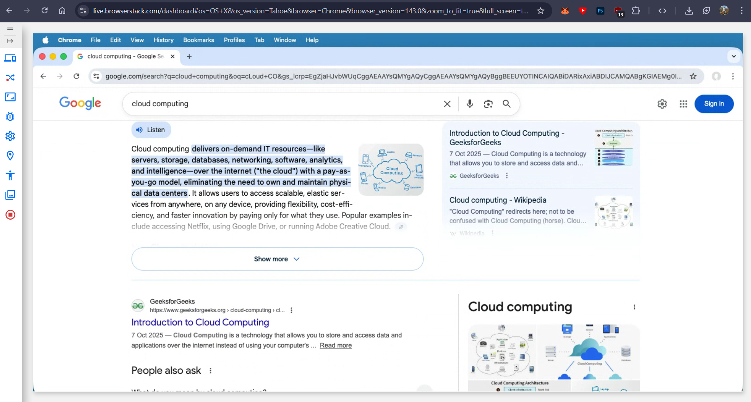
Using BrowserStack to access the Google.com

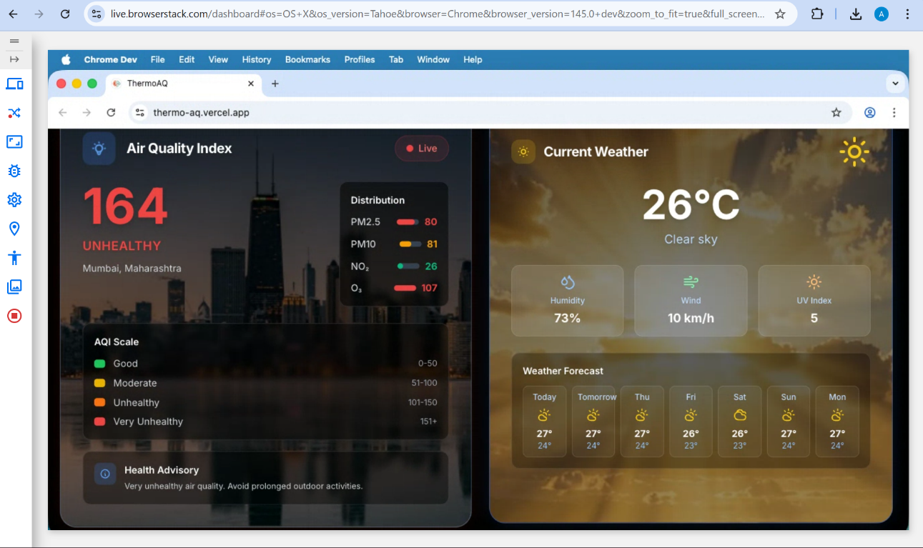
Using BrowserStack to access the website ThermoAQ (MERN Mini Project)

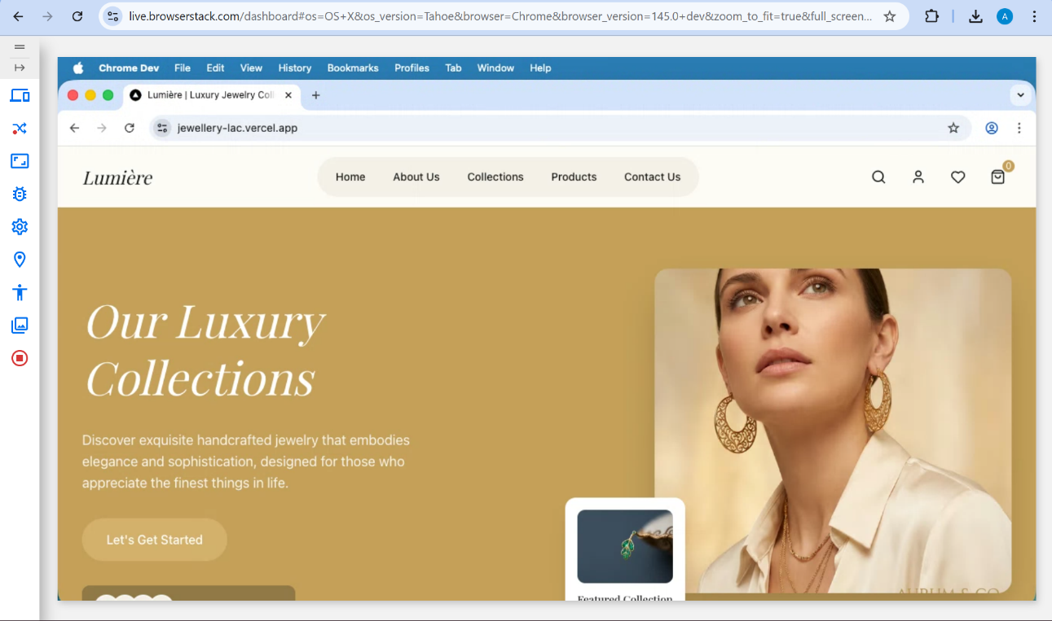
Using BrowserStack to access websites deployed using vercel

Platform 4: lambdaTest
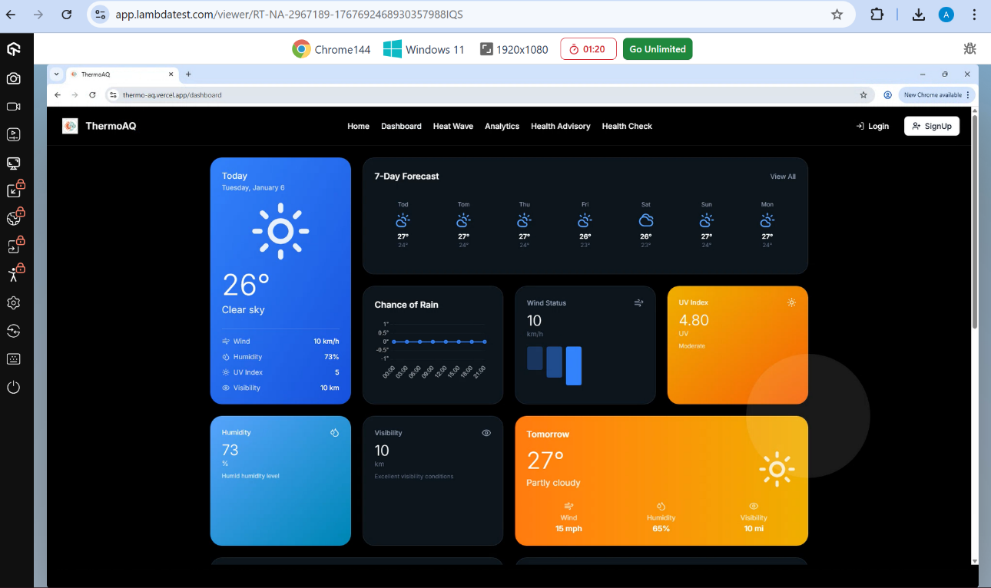
Using lambdaTest to access the website ThermoAQ (MERN Mini Project)
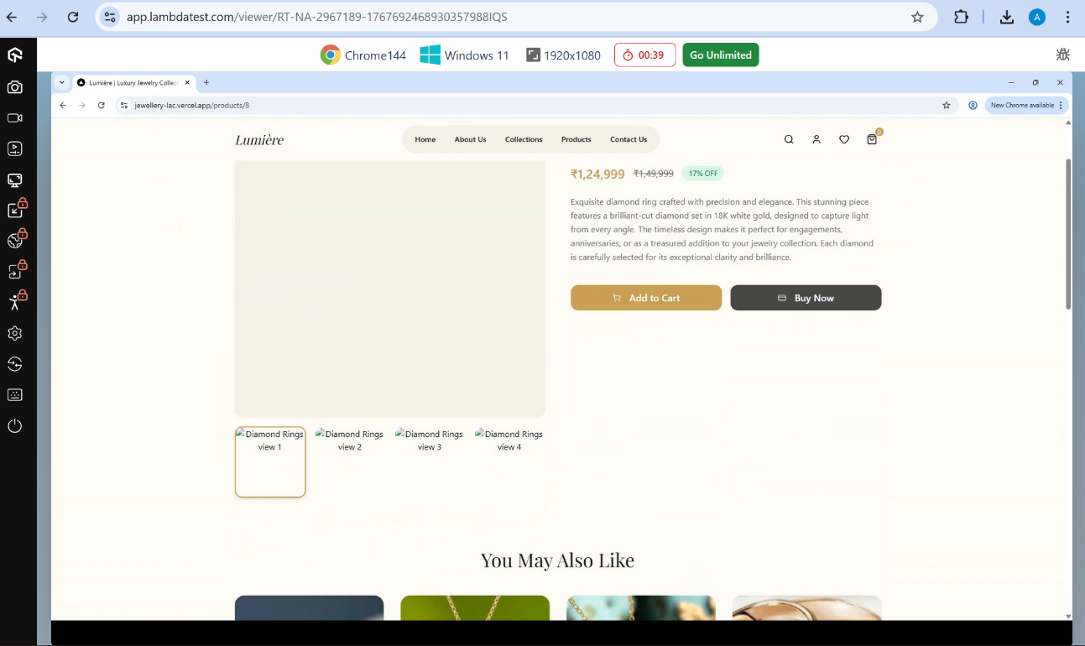
Using lambdaTest to access websites deployed using vercel
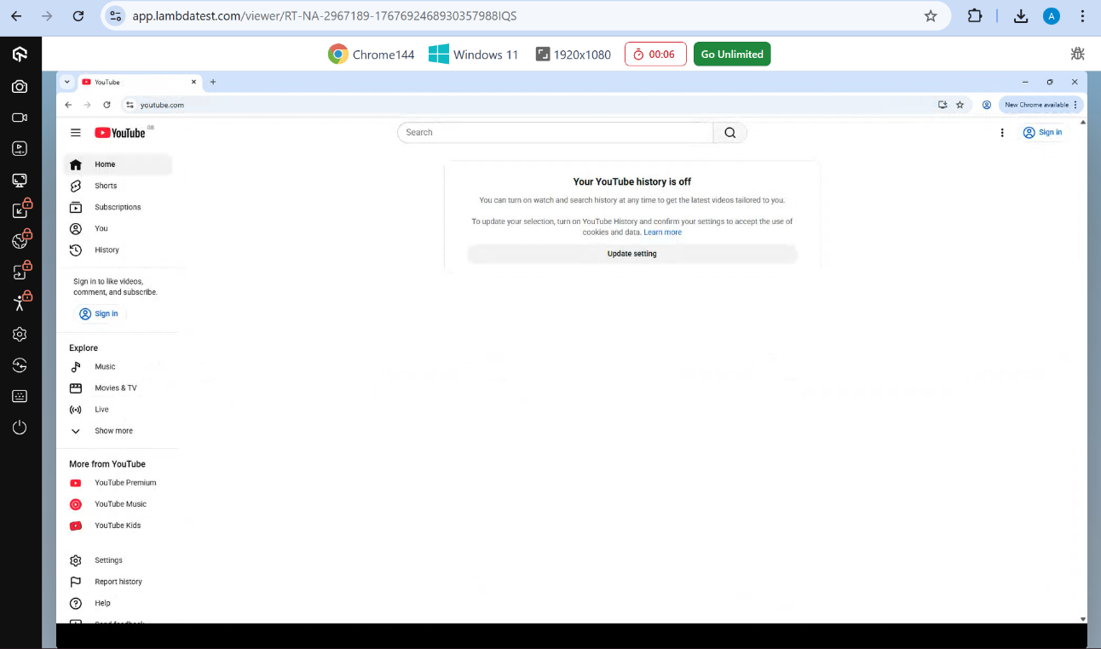
Using lambdaTest to access browser streaming services
Comparative Analysis
Compare the explored DaaS platforms based on the following parameters: - Pricing model
- Platform type (Free/Demo/Paid)
- Operating system support
- Storage availability
- User interface
- Ease of access
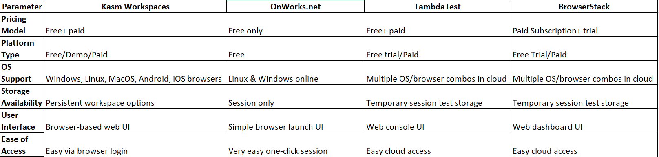
Comparison between DaaS and IaaS
Compare Desktop-as-a-Service (DaaS) and Infrastructure-as-a-Service (IaaS) with respect to level of control, target users, required expertise, and examples.
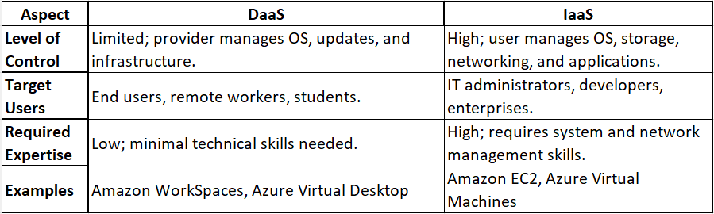

Result: Thus, the fundamentals of cloud computing were successfully studied, and the concept of Desktop-as-a-Service (DaaS) was clearly understood through hands-on exploration of multiple free and demo-based DaaS platforms. The experiment provided practical insight into browser-based desktop environments, their accessibility, usability, and real-world applicability in modern cloud computing scenarios.
Conclusion: This experiment provided a clear understanding of cloud computing fundamentals and demonstrated the practical use of Desktop-as-a-Service (DaaS) through free and demo platforms. It proved that DaaS enables secure, device-independent, and browser-based access to complete desktop environments, making it a valuable solution for modern computing and remote work applications.

